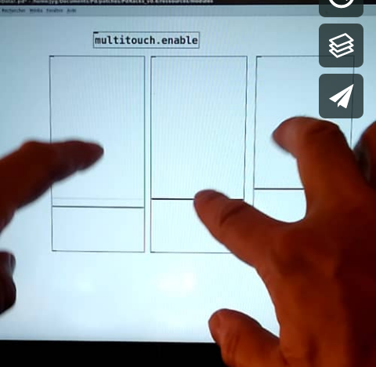
MULTITOUCH FOR PUREDATA

Enabling pseudo-multi-touch mode
with pd-native guis, inside any patch.
Demo here : https://vimeo.com/292789121

Setup
- OS : linux
- Hardware : pc with multitouch screen.
- Puredata >= 0.49
- Externals : iemguts lib, hcs/screensize (optional)
- A patched version of hid external, that reads screentouch events.

How it works
The multitouch events from touchscreen device are captured with hid external. Then, they are converted in serialized mouse events (i.e. for each touch event, one message mouse immediately followed by a message mouseup with an offset corresponding to the finger movement). Those messages are sent to the active patch window.
- Multitouch gestures (scrolling, zooming, pinch, etc...) shoud be desactivated on the O.S.
- Only monotouch has to work
- Open the patch multitouch.settings.pd ;
- Edit the messagebox connected to the 3rd outlet, fill it with the path to the TouchscreenSend program followed by the address of the touchscreen device on your system, ex. [open 17( ;
- According to your system, you shoud also change the screen and touch device resolution values ; You can get the touchscreen resolution by launching again evtest and specifying the device number, and then searching for the lines "Event code 60 (ABS_MT_TOOL_X)" and "Event code 61 (ABS_MT_TOOL_Y)" and getting the Max values
- Save and close the patch.
- You should now use the native pd-gui objects in pseudo-multitouch mode. Test with multitouch.enable-help.pd
- To add the multitouch features to your pd-project, you'll have to add the path to the multitouch abstractions

https://forums.opensuse.org/showthread.php/506695-Multitouch-on-ELAN-touchscreen

https://www.kernel.org/doc/Documentation/input/multi-touch-protocol.txt

